Create a list of integers from 1 to 10.

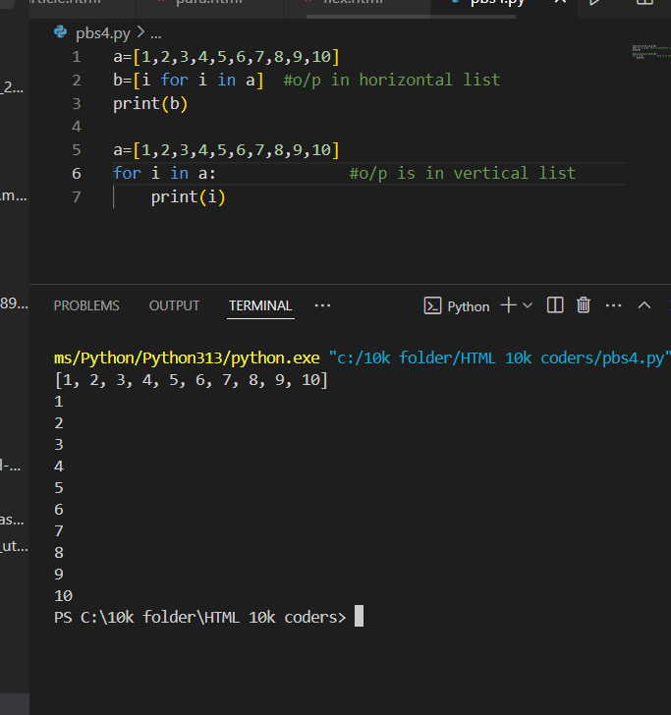

How can you access the first element of a list?

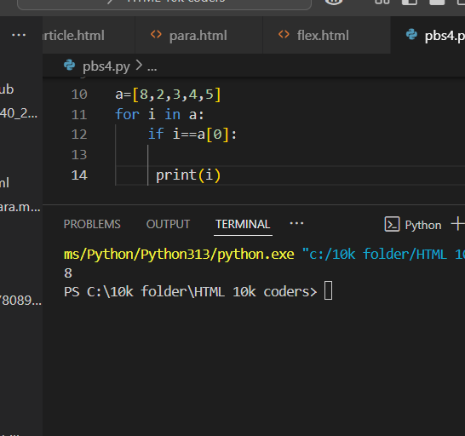

Write a Python code to append an element to the end of a list.

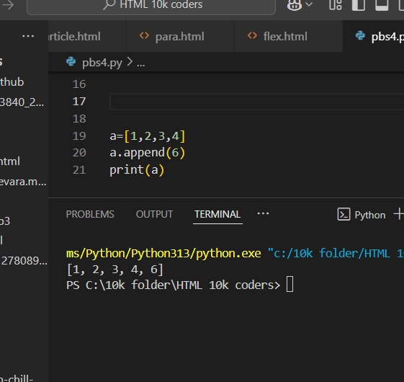

How do you remove the last element from a list?

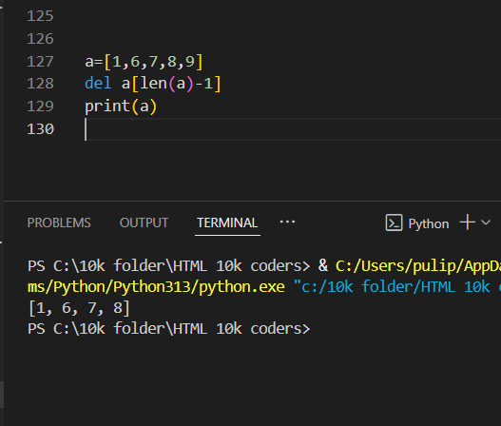

How can you find the length of a list?

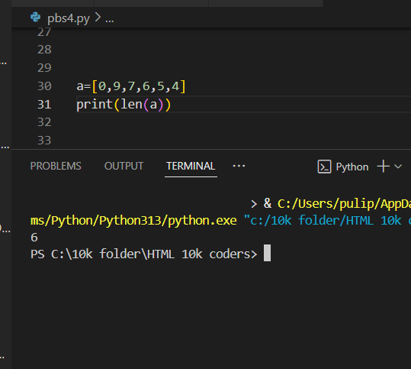

Write a Python program to find the largest number in a list.

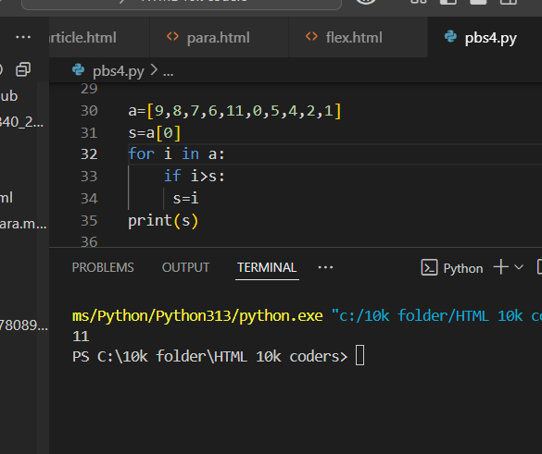

How can you sort a list in ascending order?

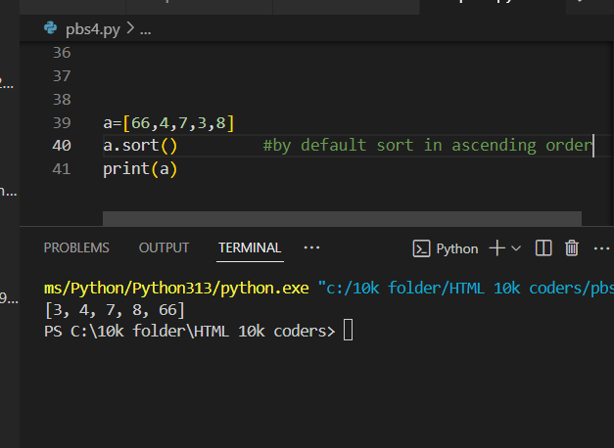

Write a code to check if an element is present in a list or not.

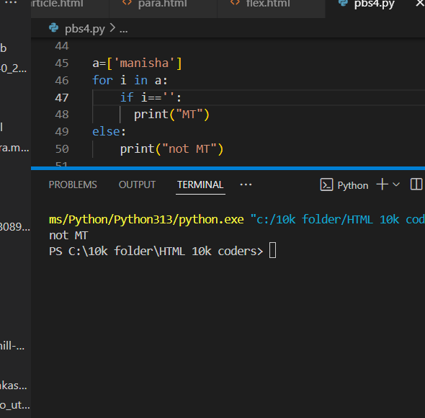

How do you find the index of an element in a list?

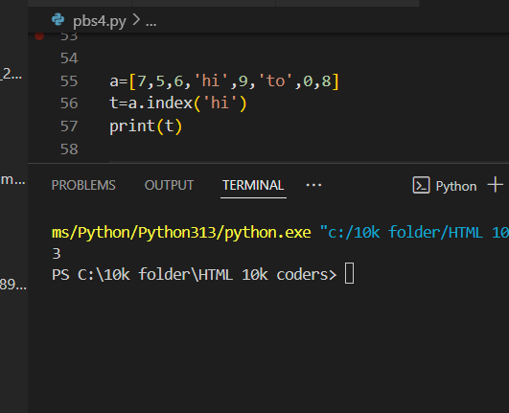

How can you create a list of 5 elements, then remove all of them?

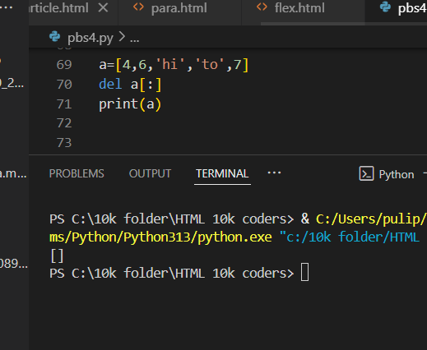

How can you slice a list to get elements from index 2 to 5?

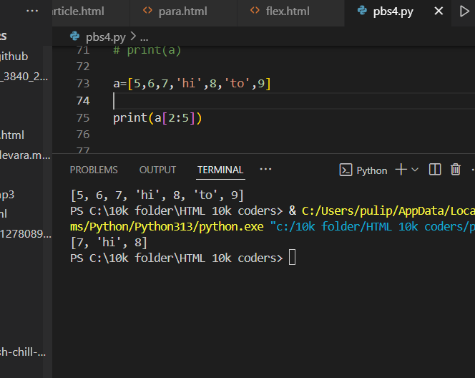

How can you concatenate two lists in Python?

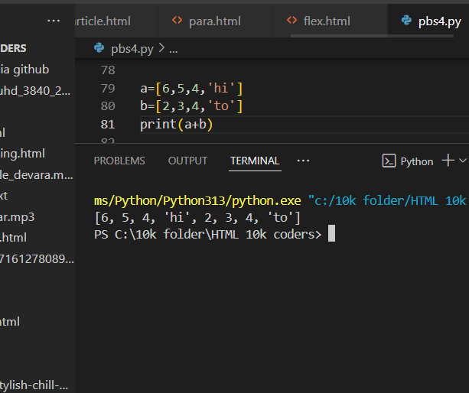

How can you copy a list into another list?

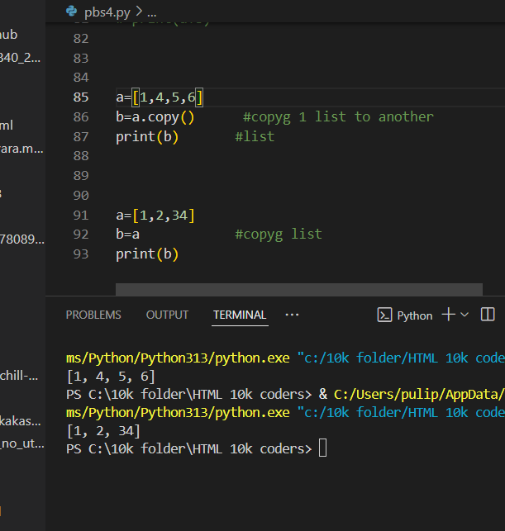

Write a Python program to count the number of times an element appears in a list.

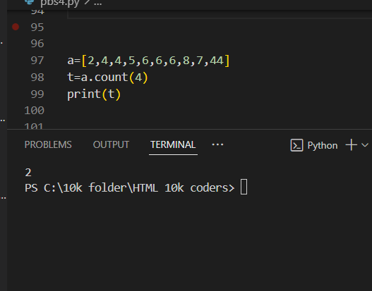

How can you check if a list is empty?

String Questions:

Create a string variable that holds your name and print it.

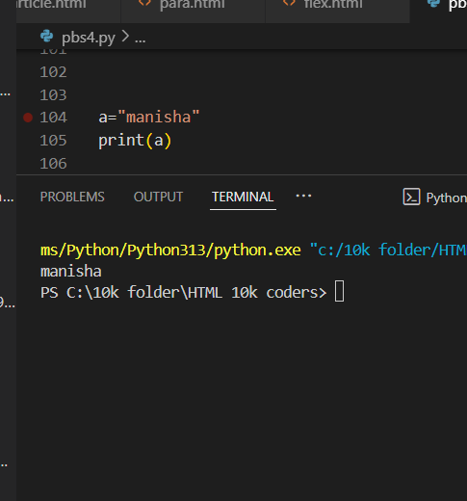

How do you convert a string to uppercase in Python?

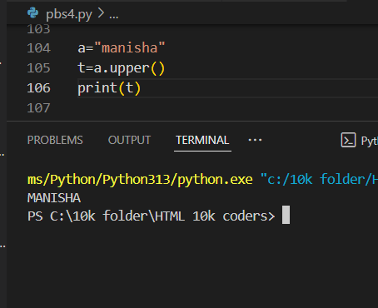

Write a code to check if a string contains a specific substring.

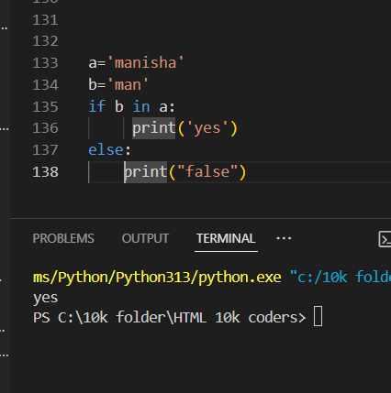

How can you find the length of a string in Python?

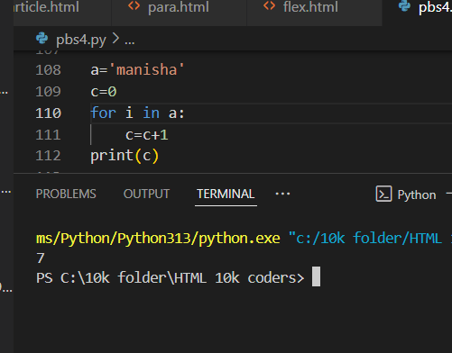

Write a Python program to reverse a string.

